**PROJECT 2 - VAWT DESIGN**

The aim of this project is a preliminary design of a H-Shaped turbine using the Double Multiple Stream Tube theory (DMST) applied to finite elementary volumes.

In order to reduce the computational time of the code we have decided to use an array syntax, in this way for every “while” cycle the code will provide all the characteristics of half of the complete rotation.

**Attack Angle Variation**

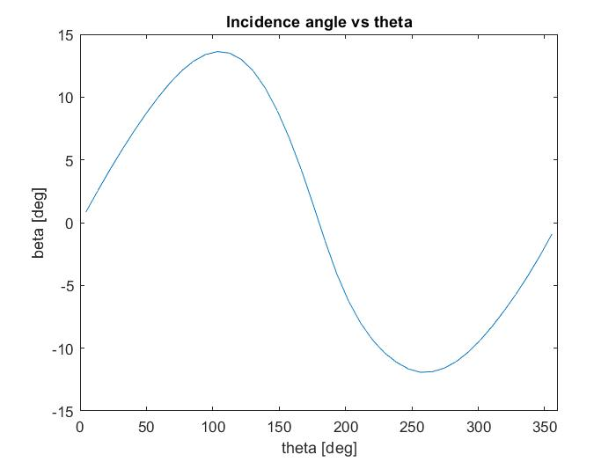The variation of attack angle of the profile is connected to the blade position along the circumference. In particular, it will be zero at 0° and 180° because the wind velocity is parallel to the peripheral speed. Also, there is a sharp increase from the downstream to windward part, because the profile is starting to face the wind, increasing its relative velocity. In the upstream part the profile will reach the maximum lift coefficient and then it will start to decrease: moving from up stream to leeward position the tangential velocity will change its direction following the wind one, so the attack angle will start to drop down until it reaches zero at 180°.

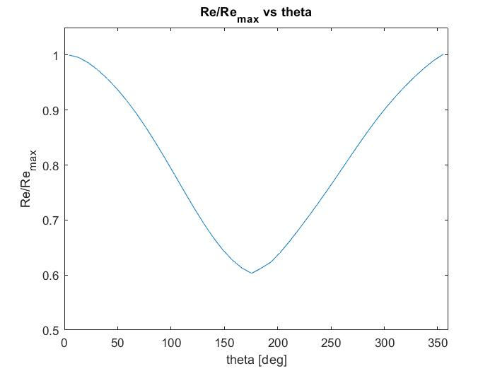**Reynolds Number**

Also, Re will follow the attack angle trend. It will reach the maximum in 0° because the tangential velocity is completely opposite to the wind one and so the relative velocity will result as the sum of them.

On the other hand, at 180° the two velocities have the same direction, so the relative one is the difference, thus Re will reach the minimum value. Due to this in the leeward region there will be the probability of stall condition.

**Induction Factor**

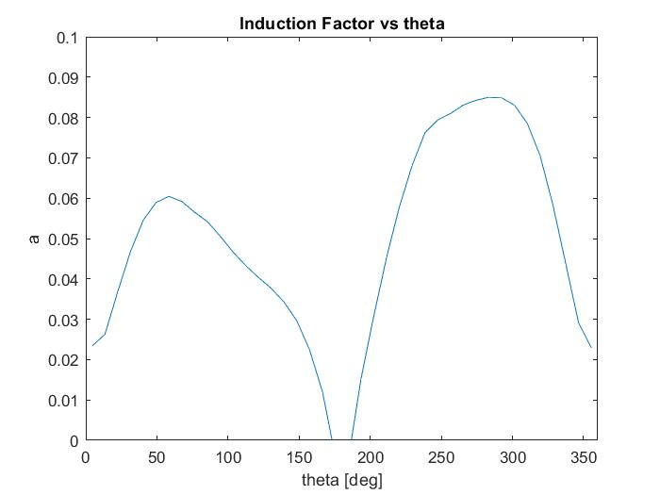The induction factor is the portion of wind velocity lost before reaching the blade.

In DMST there are two different actuator disks: the upwind and the downwind. The trends are quite similar but the second one has higher values due to the stream expansion induced by the first one. In fact, the second disk will exploit only a portion of the incoming wind flow due to the conservation equation.

There are also other effects to be considered like the presence of the blades upstream, the struts, the shaft and the uncomplete full wake condition.

**Torque analysis**

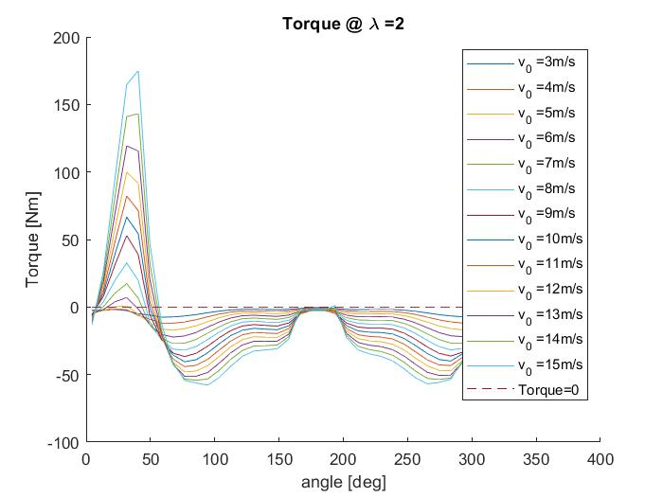To estimate the power produced by the turbine, it’s necessary to evaluate the torque. To evaluate the tangential component of blades motion, a projection on theta and beta is needed. The trend so is connected at first at beta, because it’s the first parameter which will influence the aerodynamic force coefficient. The attack angle, as already said, will increase from downstream to windward section, from negative to positive values, also changing the lift coefficient, letting a rapid increase of torque, before reaching the flag condition al 0°, when the lift is completely null, and no tangential forces are generated. After this condition, lift starts to increase again: the windward zone presents the most efficient part of profile efficiency and so, in this trait, the torque will reach the highest values, especially when theta is around 90°. But the problem is at the beginning of the leeward zone. Here in fact, the attack angle will change its sign, creating also with the blades: only the Reynolds number now is the parameter useful to understand if the profile will reach the Stall condition. When tip speed ratio is very low, so for very slow machines, the relative velocity will result in this phase very low as the Reynolds number associated. For this reason, the wind flux has not sufficient energy to cross the profile length, causing the detachment of the veins and reaching the Stall (for vary small values of tip speed ratio, also before 90° the Stall is 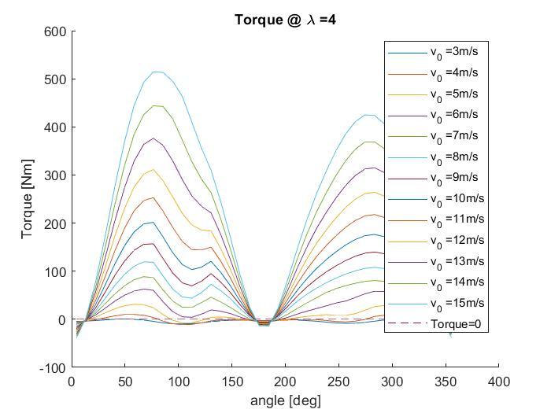reached). In graphs is clearly evident how sharp is the loss of torque in this region, keeping also negative values that is to say that the machines is not able to provide torque but its needed to keep motion survive to drag forces. Near the flag position at 180°, anyhow, the attack angle will be reduced a lot, letting the profile to regain efficiency and also positive Torque: the effect is very small, but it’s present in the trends. For higher values of tip speed ratio instead, Reynolds number provides a good condition to profile, keeping high the tangential component and also the relative velocity: in this way Stall will be not reached and a completely symmetrical trend of torque is displayed in the graphs. Is also important the fact that for too high values of tip speed ratio, the tangential component will prevail in 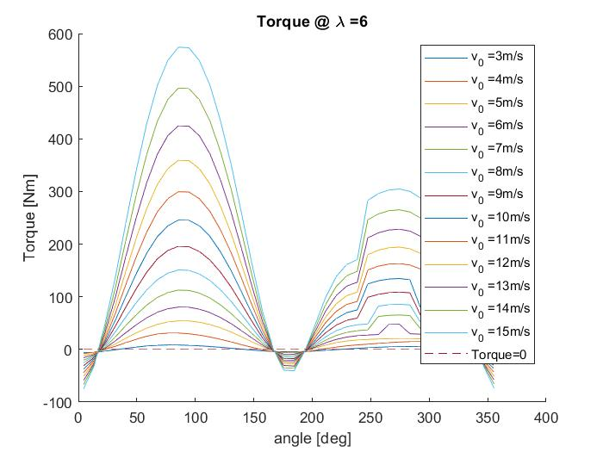the velocity triangles, keeping the attack angles very small and avoiding a complete develop of profiles: so lift will always remain very low along all parts of circumference, reducing everywhere the torque and also the power generated. Torque is correlated to wind velocity obviously, in fact when it increases, the attack 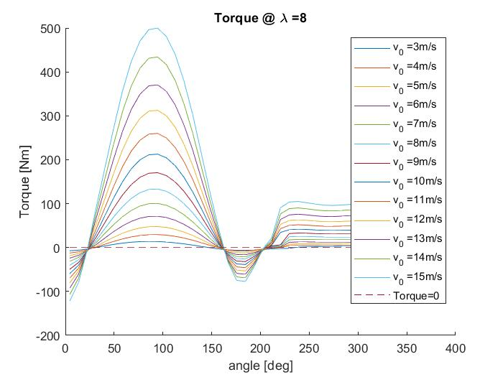angles will become bigger, making profiles to reach better efficiency at higher Reynolds numbers. Coefficient of Lift and Drag are non-dimensional parameter, so when the theoretical wind thrust increases, also the forces will be affected.

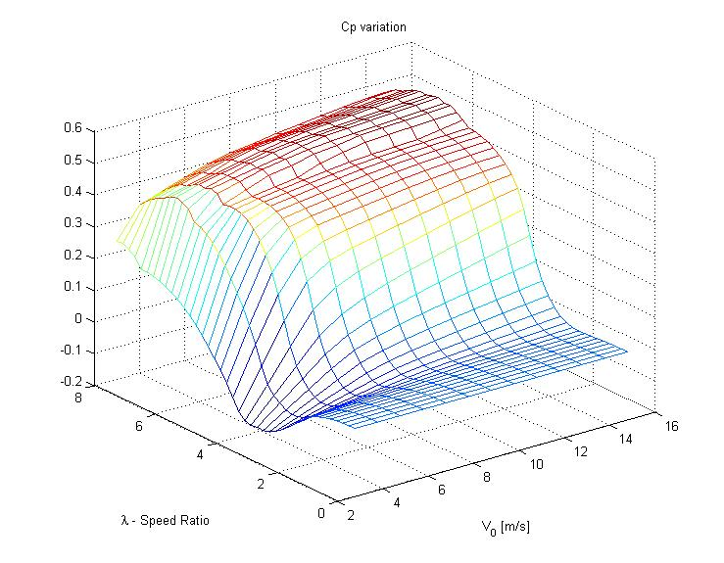**CP trend**

It is important also to consider the Coefficient of Power, which is strictly connected to the torque trend. The mesh displayed has the first x-axis which is the variation of wind velocity incoming, with reasonable values; the second y-axis which is the variation of tip speed ratio, which can be fixed for a big machine directly connected to the grid or variable for small machine coupled with an Inverter. Anyhow, it can be visible how the Cp will vary in different condition. The problem at low Lambda of Torque is also showed in the trend, where Cp will not reach a significant value, more or less always zero. When the tangential component is sufficient to have a good Reynolds number and attack angle values, the Cp rapidly increase, reaching a maximum value around 0,51. Then after this phase, the problem of limitation in attack angle values due to high tangential component will occur, reducing the Cp. Velocity of wind is very detrimental for performances when it’s very low, at the star up of the machine for example, but then, when the profiles will reach a good interaction with the flux, only a small increase is showed. So is clear that the wind velocity will increase always the Cp of the machine if the Lambda is appropriate to let profiles to reach the correct efficiency; but Lambda cannot always be increased, or the tangential component will reduce too much the attack angle and the torque. Wind velocity is also very important to evaluate the axial forces and so to properly design the structure of the turbine.

**Conclusions**

In the end, from this analysis, it’s possible to say that a VAWT can compete with HAWT in some range of applications, but its modeling is harder, because there several effects that cannot easily implemented in a design code. Effects like dynamic Stall reached in leeward zone or the losses introduced by the presence of struts or the not completely far wake state at the incoming velocity for the second actuator disks. There are several activities in research in order to establish a relation to be easily implemented in a code. Another point is that there are no limits to lambda in this studio: in HAWT the tip speed ratio has to be blocked in order to avoid mechanical problems in blades; in this case also it’s reasonable to think to a possible maximum lambda for structural reasons or that can introduce vibrations. These machines are very interesting for an urban application, where at low wind speed, with a reasonable lambda, it is possible to reach a good Cp value, with a small structure instead putting a very large rotor design like a HAWT, with all problems associated. In future, probably, a great number of these will be installed, to gain power from wind where the classical and well design HAWT cannot be used.